Three Dimensional Arrays

A three dimensional array is just an extension of the concept of a two dimensional array or matrix. In the two dimensional case we had rows and columns. In the three dimensional case we have rows, columns, and sheets. A picture of a 3x5x3 array, where we have specified this as 3 rows, 5 columns, and 3 sheets would be:

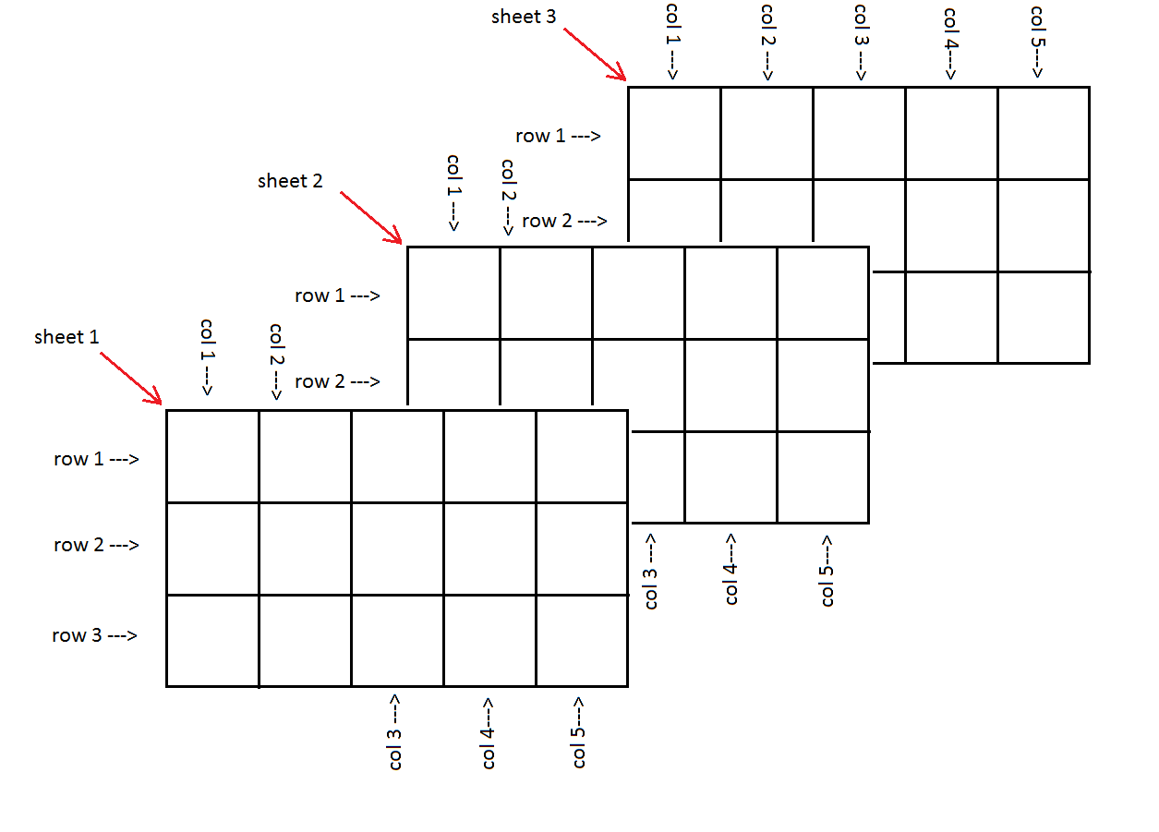

If this is the matrix, or array, C then an element of that array could be denoted as Ci,j,k where i indicates the row, j indicates the column, and k indicates the sheet of the element. In a programming language this reference might be written as C[I,J,K] or C(I,J,K) or C[I][J][K], depending upon the particular language.

To reinforce this concept, consider the 3x5x3 array shown below as C with values in the particular cells (elements) of C.

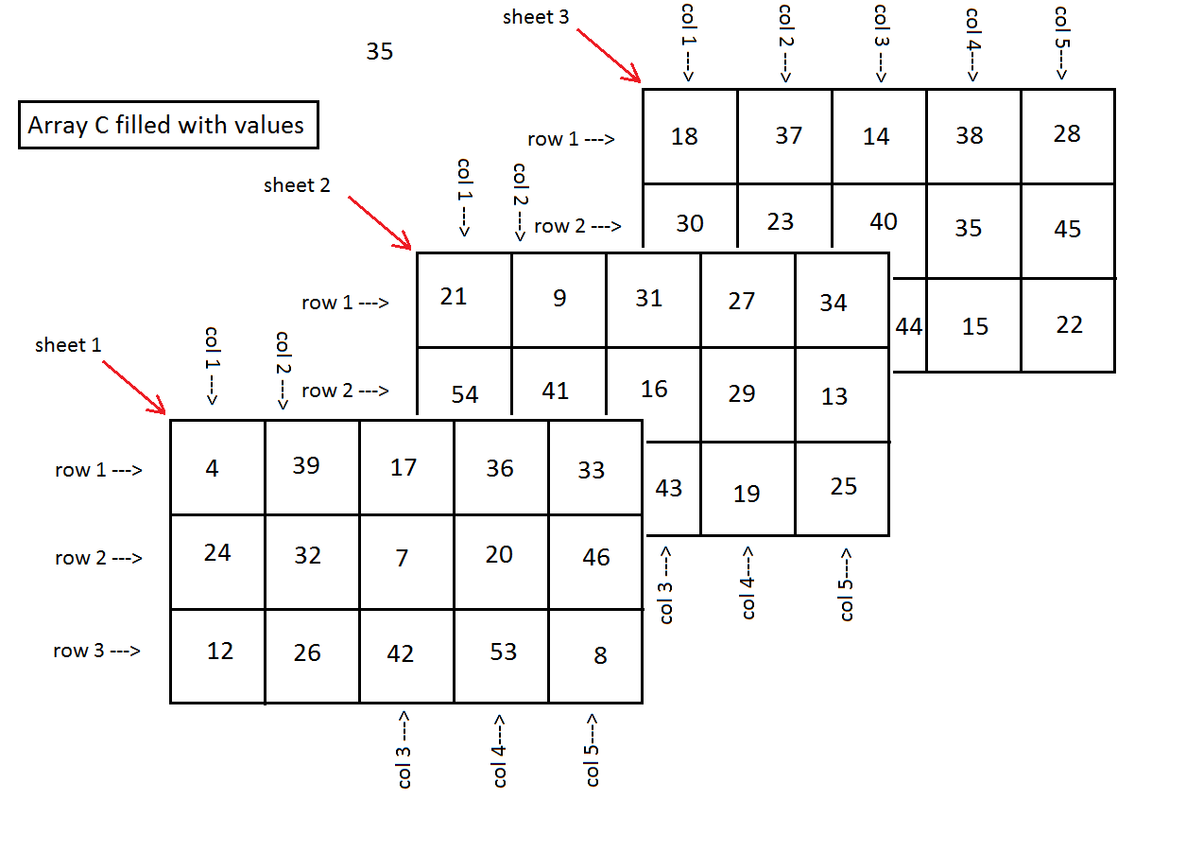

Now we can look at row 1 column 2 sheet 3, that is element C1,2,3 to see that it holds the value 37. Similarly, C2,3,1 holds 7 and C2,1,2 holds 54.