Subscripted Variables Extended

In the introduction to subscripted variables we happened to see an example of Huron’s formula: for a triangle with sides L1, L2, and L3 we define “s” to be the half perimeter equal to the sum of the sides divided by 2, or s=(L1+L2+L3)/2. Just as a demonstration, let us slightly alter that approach for a more complex problem. Let us say that we are given a polygon, here we will use a pentagon, but it need not be a regular polygon. Thus the sides are of different lengths and the angles between the sides also change. The one requirement here is that we have five sides and that this is a “convex” polygon, that is, a line connecting any two points inside the polygon stays entirely inside the polygon. If that is the case then we can take any point inside the polygon and create radii to the vertices of the polygon, as in:

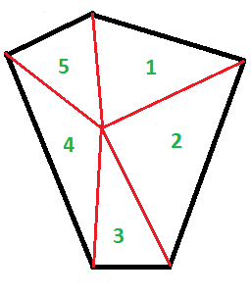

Note that we have numbered the triangles 1 through 5. Now, if we are given all of the lengths of the sides, and if we are given the lengths of the radii, then we can find the area inside the polygon. To express this in variables we need to assign variables to the values that we know. In our case we have five edges, let us call them e1, e2, e3, e4, and e5. Furthermore, we have five radii which we will call r1, r2, r3, r4, and r5. We see the five triangles in the diagram along with the labeled values.

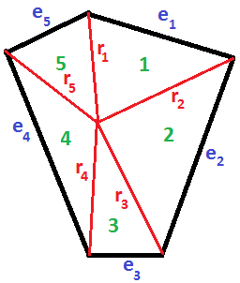

Having done this we can define the half perimeter for triangle 1 as s1=(r1+e1+r2)/2. Then the half perimeter of triangle 2 is s2=(r2+e2+s3)/2 and so on until we get to s5 where we woud have to change the pattern to get s5=(r5+e5+r1)/2. Note the use of r1 instead of the expected r6. This breaks the earlier pattern that we had, si=(ri+ei+ri+1)/2. We can actually fix that so that things always work by introducing a second name for r1, namely, r6. This is shown in the diagram.

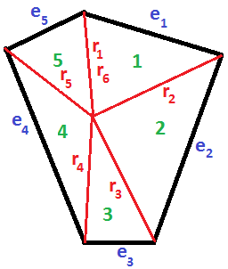

Now our general definition of the half perimeter is consistently si=(ri+ei+ri+1)/2. With that we can express the area of each triangle as a subscripted variable ai where ai=square root of si(si-ri)(si-ei)(si-ri+1). And, the total area is just a1+a2+a3+a4+a5.

We have done this example with an irregular but convex pentagon. The same scheme could be applied to any convex polygon. This is the power of subscripted variables.